Provisional Patent Application of
Thomas E. Bearden and Kenneth D. Moore
Increasing the Coefficient of Performance of Electromagnetic Power Systems by Extracting and Using Excess EM Energy from the Heaviside Energy Flow Component

Inventors: Thomas E. Bearden
Huntsville, AL 35801-1351

Kenneth D. Moore
Huntsville, AL 35801

Address correspondence to:
Thomas E. Bearden
Huntsville, AL 35801-1351

References Cited:
- Bearden, Thomas E. (2005) “Errors and Omissions in the CEM/EE Model”, available from http://www.cheniere.org/techpapers/CEM%20Errors%20-%20final%20paper%20complete%20w%20longer%20abstract4.doc . The paper presents and discusses known serious errors and falsities that have been in the classical EM and electrical engineering model since it was put together in the 1880s, and since 1892 when the already-seriously-curtailed Maxwell-Heaviside equations were further arbitrarily symmetrized by Lorentz. By his symmetrical regauging, Lorentz obtained simpler equations easier to solve analytically, but in so doing he arbitrarily discarded all asymmetrical Maxwellian systems. Nature does not discard them; Lorentz did and our electrical power engineers still do, as shown by any current classical electrodynamics text such as Jackson’s Classical Electrodynamics.
Comment: The present invention deliberately uses an asymmetrical Maxwellian system to provide a novel excess EM energy collection directly from a previously unaccounted free flow of EM energy from the external vacuum environment. In addition to the accounted Poynting energy flow, there also is and always has been an unaccounted and huge Heaviside curled component of energy flow which was also discarded arbitrarily by Lorentz, and continues to be discarded to the present day. By using not only the Poynting energy component input paid for by the operator, but also using an extra and free input of additional Poynting energy flow gained from converting some of the previously unaccounted Heaviside energy flow input into Poynting (diverged) energy flow, the absorbing system is enabled to absorb and emit more Poynting energy than the operator alone inputs and pays for in his Poynting input component only. Conservation of energy is obeyed. The resulting system does not ever emit more energy than its total energy input, when one understands and accounts the previously unaccounted huge Heaviside input component always accompanying the Poynting input component but ignored since Lorentz arbitrarily discarded it. Thus the thermodynamic efficiency ξ of the resulting system always remains ξ ≤ 100%, but its thermodynamic coefficient of performance COP is permitted to be COP > 1.0 because the asymmetric system now receives an extra free and usable EM energy input from its environment.
- Bearden, T. E. (2000) "Giant Negentropy from the Common Dipole," Proceedings of Congress 2000, St. Petersburg, Russia, Vol. 1 (86-98). Also published in Journal of New Energy, 5(1), Summer 2000, p. 11-23. Also carried on website www.cheniere.org. This paper presents the solution to the long-vexing source charge problem: how a charge can continually pour out real observable EM energy (real photons) at light speed in all directions, but have no observable output. The charge absorbs disordered virtual state energy from the virtual state vacuum, reorders them, coherently integrates the virtual state energy excitations into the next quantum level excitation, and then abruptly decayse by emitting an observable photon. Iteration of the process gives the observed emission of observable photons, with no observable energy input since the energy input is in the virtual state form.
- Bearden, T. E. (2002) Energy from the Vacuum: Concepts and Principles, Cheniere Press, Santa Barbara, CA. Chapter 3. “Giant Negentropy, Dark Energy, Spiral Galaxies and Acceleration of the Expanding Universe”.
- Bohren, Craig F. (1983) "How can a particle absorb more than the light incident on it?" Am. J. Phys. 51(4). (323-327). Under nonlinear conditions, a charged particle can absorb more energy than is [conventionally considered to be] in the light incident on it. Metallic particles at ultraviolet frequencies are one class of such particles and insulating particles at infrared frequencies are another. [We strongly note that the conventional view only accounts the Poynting energy flow component of the total energy input, and ignores the huge Heaviside input component that is nonetheless present and many orders of magnitude greater.]
Comment: When the charged particles in a medium are self-resonant at the same frequency of the light energy that is input to the medium, the medium can re-radiate up to 18 times as much energy as is in the Poynting component of the input energy. The conventional model (i) assumes field strength determined by absorption due to the reaction cross section of a static charge, and (ii) completely neglects the enormous Heaviside curled energy flow component, while considering only the Poynting energy flow component as determined by an absorbing static charged particle. For working in the IR and thus with heat energy, the “charged particles” in the medium are charges existing on insulating particles, where the charged particles are deliberately made self-resonant at the proper IR frequency or band. For broader band introduction of heat (IR) energy input, the overall gain reduces from the optimal 18, but still may be greater than 1.0 due to the increase of the overall reaction cross section of the absorbing charges where some are in self-oscillation. Gains of 3.0 to 4.0 can be achieved in conventional practice, and under certain circumstances the optimum 18 can be approached by multiple stages each having cross-feed forward and backward with all the rest.
- Electrician, The. (1891) Editorial, "The transfer of energy." The Electrician, Vol. 27 (270-272). Quoting: "...the idea that energy is located at all, and that, when it changes its position, it must move along a definite path, is quite a new one. The law of the conservation of energy implies that energy cannot disappear from one place without appearing in equal quantity somewhere else; but, although this fact has long been accepted, it is only within the last few years that the idea of transference of energy has been developed, or that anyone has attempted to trace out the actual path along which energy flows when it moves from place to place. The idea of an energy current is of more recent date than the electro-magnetic theory, and is not to be found explicitly stated anywhere in Maxwell's work. We believe that the first time it was applied to electrical theory was in the pages of The Electrician, by Mr. Oliver Heaviside, to whom so much of the extension of Maxwell's theory is due. The idea was also independently developed and brought to the notice of the Royal Society in a Paper by Prof. Poynting."
- Evans, D J. and Lamberto Rondoni (2002). "Comments on the Entropy of Nonequilibrium Steady States," J. Stat. Phys., 109(No. 3-4), Nov. 2002, p. 895-920. The authors rigorously demonstrate that in thermodynamics theory physical systems capable of continuously
producing negative entropy are theoretically permissible and possible, though unknown.
Comment: Bearden has previously solved the source charge problem (Bearden, 2000), and has formally proposed the source charge and the source dipole as the first two known physical EM systems that continuously produce just such negative entropy. In modern physics, the “classically isolated charge” polarizes its surrounding vacuum, so any classical charge is a priori a dipolar assembly. Two infinite charges and two infinite energies are actually involved (see Weinberg), even for a single charged particle such as a single electron. Obeying the broken symmetry of opposite charges (Lee and Yang, experimental proof by Wu et al.), any charge or dipole consumes positive entropy of the disordered virtual fluctuations of the vacuum, and produces negative entropy in the observable state⎯by continuously emitting real observable photons in all directions but receiving no observable energy input. It does receive the necessary energy input, but from the seething virtual state vacuum. Since the “isolated charge” involves two infinite charges and two infinite energies, a steady and finite flow of energy for any finite time can and will be sustained by the charge’s infinite energies without any diminishing of the energy flow.
- Evans, M. W. et al. (2000) “Classical Electrodynamics without the Lorentz Condition: Extracting Energy from the Vacuum,” Physica Scripta, 61, (513-517). This paper rigorously proves that an asymmetrical system not obeying the Lorentz symmetry condition does freely receive excess energy currents from its vacuum environment, and thus is permitted to receive and use excess energy from said environment.
- Feynman, Richard P., Robert B. Leighton, and Matthew Sands, The Feynman Lectures on Physics, Addison-Wesley, Reading, MA, Vol. 1, 1964, p. 12-2. Quoting: "…in dealing with force the tacit assumption is always made that the force is equal to zero unless some physical body is present… One of the most important characteristics of force is that it has a material origin…"
- Feynman et al., ibid., Vol. 1, p. 2-4. Quoting: "…the existence of the positive charge, in some sense, distorts, or creates a "condition" in space, so that when we put the negative charge in, it feels a force. This potentiality for producing a force is called an electric field."
- Feynman et al., ibid., Vol. 2, p. 1-3. Quoting: "We may think of E(x, y, z, t) and B(x, y, z, t) as giving the forces that would be experienced at the time t by a charge located at (x, y, z), with the condition that placing the charge there did not disturb the positions or motion of all the other charges responsible for the fields."
- Halliday, David and Robert Resnick, with assistance of John Merrill. (1988) Fundamentals of Physics, Third Edition Extended, Vol. II, p. 743, 753, 766-767. For the self-induced EMF in a coil by changing the current (or the voltage), only the rate of change counts, not the amount of change. Thus a large momentary magnetic field can be produced by an abrupt change of a very small current or of a very small voltage. The rate of change of the magnetic field also creates an electric field, and so the more abrupt the magnetic field change, the greater the momentary E-field that is produced. Lenz's law shows that the sign of the induced EMF and MMF is always opposing the change.
- Halliday, David and Robert Resnick, ibid., p. 858. The intensity of the Poynting vector S varies as the square of the E-field. In turn, the magnitude of the momentary E-field varies as the abruptness of change of the magnetic field. Thus for an abrupt Lenz law change of voltage (by an abrupt small current change) across a small double surface, a very large E-field momentarily results. The resulting momentary pulse of Poynting energy flow intensity is proportional to the square of that momentary large E-field. It can be seen that the Poynting energy pulse is proportional to the square of the magnitude of the abrupt Lenz reaction fields. It follows that such a giant pulse of Poynting energy flow suddenly propagating across substantial intercepting charges q leads to interception and absorption of energy on charges q, leading to the potentialization of charges q and therefore to their asymmetrical regauging.
- Heaviside, Oliver. (1885, 1886, 1887) "Electromagnetic Induction and Its Propagation." The Electrician, 1885, 1886, 1887, and later. A series of 47 sections, published section by section in numerous issues of The Electrician during 1885, 1886, and 1887.
- Heaviside, Oliver. (1887) Electrical Papers, Vol. 2 (94). Quoting p. 94: “It [the energy transfer flow] takes place, in the vicinity of the wire, very nearly parallel to it, with a slight slope towards the wire… . Prof. Poynting, on the other hand, holds a different view, representing the transfer as nearly perpendicular to a wire, i.e., with a slight departure from the vertical. This difference of a quadrant can, I think, only arise from what seems to be a misconception on his part as to the nature of the electric field in the vicinity of a wire supporting electric current. The lines of electric force are nearly perpendicular to the wire. The departure from perpendicularity is usually so small that I have sometimes spoken of them as being perpendicular to it, as they practically are, before I recognized the great physical importance of the slight departure. It causes the convergence of energy into the wire.”
Comment: Here one can see that the Poynting component is only a very slight diverged fraction in magnitude, compare to the otherwise nondiverged giant energy flow remaining. The actual diverged Poynting energy flow into the wire is only a “slight departure” from the outside energy flow discovered by Heaviside. So a much larger usually nondiverged Heaviside energy flow remains, in addition to the small Poynting energy flow component usually entering the circuit to potentialize the charges q and excite the circuit for its collection of potential energy.
- Heaviside, Oliver. (1893) "On the Forces, Stresses, and Fluxes of Energy in the Electromagnetic Field." Phil. Trans. Roy. Soc. London, 183A, p. 423-480. Heaviside discusses the Faraday-Maxwell ether medium, outlines his vector algebra for analysis of vectors without quaternions, discusses magnetism, gives the EM equations in a moving medium, and gives the EM flux of energy in a stationary medium. On p. 443, he credits Poynting with being first to discover the formula for energy flow, with Heaviside himself independently discovering and interpreting this flow a little later by himself in an extended form.
Comment: In the present invention we deliberately take advantage of that huge but usually nondiverged Heaviside energy flow remaining after the typical small Poynting energy flow is diverged into the circuit. By deliberately using self-oscillation of the intercepting charges rather than the (assumed) fixed (static) charge utilized in the standard definition for field and charge interaction, the additional Lenz law effect produced by the sharp change of charge location and interception dramatically increases the reaction cross section of the now-self-oscillating charges compared to the same charges in “static” condition. This results in a very sharp, strong gradient applied to the Heaviside energy flow component, in fact diverging some of its usually unavailable energy into the circuit to overpotentialize the self-oscillating charges. The result is that up to 18 times the usual Poynting energy flow onto these charges to potentialize them, is realized and made available for the system’s use. It is strongly accented that this is a method of utilizing part of a known (but usually unaccounted) huge excess energy flow that is universally made to every present circuit but ignored. Thus the thermodynamic efficiency of the system never exceeds 100% under any circumstance, but its coefficient of performance (COP) is permitted to appreciably exceed COP = 1.0. In short, the external environment containing the usually unaccounted and ignored extra Heaviside energy flow component is stimulated to freely provide and excess and extra Poynting energy flow component to the self-oscillating charges. The system becomes analogous to any EM system freely receiving excess EM energy from its environment, in addition to that standard accounted input by the operator. As a comparison, because of its usable excess energy input from its environment, a home heat pump with an efficiency of 50% will usually produce a COP = 3.0 to 4.0. By triggering an additional usable excess energy input from the environment’s normally unusable Heaviside energy flow component, the present invention is permitted a maximum theoretical COP = 18. For real systems with losses, the achieved COP will be lower than 18, but can still be appreciably greater than COP = 1.0. E.g., achievement of COP = 2.0 to 5.0 are rather readily achievable, and in multi-staged systems the optimum COP = 18 can be approached.
- Heaviside, Oliver. Unpublished notes. See Josephs (1959). Heaviside realized that his enormous extra nondiverged energy flow component had substantial gravitational consequences, since it was a substantial change in the local density flow of space, and thus a curvature of spacetime. Heaviside went back to quaternion theory, and worked out an electrogravitational theory could conceivably re implemented in circuits and EM practice.
Comment: We cite these notes to point out that use of excess energy from the Heaviside component involves use of a deliberately curved spacetime, and this effect does not appear in normal CEM/EE where only special relativity is involved and the model assumes spacetime to be flat.
- Jackson, J. D. (1999) Classical Electrodynamics, 3rd Edn., John Wiley and Sons, New York (249, 246). For the vacuum, Maxwell's equations reduce to two coupled equations, shown as equations 6.10 and 6.11 on p. 246. The Lorentz regauging condition is applied by Jackson on p. 240, resulting in two inhomogeneous wave equations given as equations 6.15 and 6.16. The Lorentz condition is given in equation 6.14 on p. 240. On page 240, Jackson erroneously states that "Equations (6.15) and (6.16), plus (6.14), form a set of equations equivalent in all respects to the Maxwell equations." Comment: To the contrary, they are not equivalent at all. Indeed, by symmetrizing the equations, all asymmetrical Maxwellian systems including those capable of exhibiting COP > 1.0 (i.e., all asymmetrical systems far from equilibrium with their local environment consisting of the local active vacuum and the local curved spacetime) have been arbitrarily eliminated by Lorentz and thus by Jackson. What is true is that the fields are invariant, and even that statement needs qualification: Two new, free fields and their energy have been arbitrarily added, but carefully so that they are equal and opposite. So the overall stress and therefore the stress energy of the system itself⎯which does not appear in the Maxwell-Heaviside-Lorentz equations⎯has been changed. In short, the curvature of local spacetime and the local active vacuum have been deterministically structured so that they produce the two extra equal but antiparallel forces. In effect, to gain simpler equations easier to solve, field energy has been added and changed into stress potential energy, which curves the local spacetime and also alters the local vacuum.
- Jackson, J. D. (1975) Classical Electrodynamics, Second Edition, Wiley, New York (219-221; 811-812.), In symmetrically regauging the Heaviside-Maxwell equations, electrodynamicists assume that the potential energy of a system can be freely changed at will (i.e., that the potential of a system can be asymmetrically regauged). Comment: This freedom to arbitrarily change the potential energy in a system, work-free, is also included under one of the major principles of quantum field theory, known as gauge freedom. Following Lorentz, the classical electrodynamicists and electrical engineers arbitrarily do two asymmetrical regaugings of the Maxwell-Heaviside equations simultaneously. But they carefully select only a very special combination of these “two asymmetrical regaugings” such that the two new free fields that emerge are equal and opposite. Thus they use only the symmetrical special case where there is no net resulting force which can be used to asymmetrically dissipate the free excess system energy resulting from regauging, and thereby perform work in a load without simultaneously performing equal work to destroy the “external” source of free potential energy flow. So the electrodynamicists and engineers arbitrarily discard all that entire class of Maxwellian systems which asymmetrically regauge by changing their own potential energy and also producing a net nonzero free force field. These latter asymmetric systems are open dissipative EM systems, freely receiving regauging energy from their active external environment. In principle such systems are permitted to asymmetrically dissipate that excess regauging energy in their external loads to power them freely. Hence the performance of the class of arbitrarily-excluded Maxwellian systems is not limited by classical equilibrium thermodynamics, but must be described by Nobelist Prigogine’s disequilibrium thermodynamics of an open dissipative system. Such open disequilibrium systems can (i) self-organize, (ii) self-oscillate, (iii) output more energy than the operator himself inputs (the excess is freely received from the external active environment) (iv) freely “power” its own losses and an external load simultaneously (all the energy to operate the system and the load is received freely from the external active environment), and (v) exhibit negative entropy.
Quoting Jackson, p. 237: "...the Poynting vector is arbitrary to the extent that the curl of any vector field can be added to it. Such an added term can, however, have no physical consequences." Second Comment: This statement by Jackson is true in vector analysis in the special case of a rigorously flat spacetime. It is not true in general, however, since the additional curled field energy density (as does any change in local energy density of space) is a general relativistic curvature of spacetime, where vector analysis fails and where the divergence of the curl is then not necessarily zero. In short, the divergence of an extra “curled” component of EM energy flow accompanying the uncurled Poynting energy flow, is not zero for a curved spacetime situation. For a significant curvature of spacetime, the usual “flat spacetime” curl-free Poynting energy flow component may be increased by an extra amount furnished by violation of the flat spacetime assumption—in which case the divergence of the curl is not zero. Jackson’s statement is approximately true only so long as the spacetime is almost flat, so that the divergence of the curl remains essentially zero. But by deliberately curving the local spacetime, the new Poynting energy flow can be augmented by an extra added diverged component from the curled energy flow component. In short, this produces an additional nonzero Poynting (divergent) energy flow component from the usually nondivergent Heaviside curled flow component, since the divergence of the curl need not be zero in that case. The system receives (absorbs) more divergent Poynting energy than the operator himself input in his ordinary Poynting energy input. So the Heaviside curled energy flow component can indeed be induced to produce an additional usable and diverged Poynting EM energy flow component. By deliberately creating nonnegligible spacetime curvature (via the oscillating free sharp energy gradients introduced by self-oscillation of the absorbing charges) that differs from that of the normal Heaviside flow region of interest, it is indeed possible to extract (diverge) extra EM energy freely from the Heaviside energy flow component accompanying every Poynting energy flow, but unaccounted. This capability and change is not modeled in, or possible in, the inadequate vector algebra used in the Maxwell-Heaviside theory and equations. Hence the mechanism for this invention does not appear in classical electrodynamics and electrical engineering, although it has been well established (but not properly understood) in physics since 1967 (Letokhov, Bohren, and others.)
- Josephs, H. J. (1959) “The Heaviside papers found at Paignton in 1957.” The Institution of Electrical Engineers Monograph No. 319, Jan. 1959, p. 70-76. This is the IEE’s publication of Heaviside’s hand-written notes containing his theory of electrogravitation, based on his theory of EM energy flow containing the huge extra curled energy flow component. The papers were found beneath the floor boards in Heaviside’s little garret apartment some 32 years after his death. His trapped EM energy flow loops were gravitational, because they constitute excess energy density in spacetime, thus curving spacetime. The late Professor Laithwaite and others (including the present inventor) were convinced that the secret of practical electrogravity starts with Heaviside’s energy flow theory where a trillion times more EM energy density of space is available to work with on the bench. For a highly successful antigravity experiment using the negative energy variant of Heaviside’s huge energy flow component, see Sweet and Bearden (1991).
- Kondepudi, Dilip and Ilya Prigogine. (1999) Modern Thermodynamics: From Heat Engines to Dissipative Structures. Wiley, New York, 1998, reprinted with corrections 1999. Areas known to allow violating the second law thermodynamics are given on p. 459; one such area is a strong gradient. Indeed, the gauge freedom axiom of quantum field theory, in establishing that the potential energy of an EM system can be freely increased without work, is one specification for violation of the hoary old second law of thermodynamics which must be corrected.
- Laithwaite, E. R. (1982) “Oliver Heaviside—establishment shaker.” Electrical Review, 211(16), Nov. 12, 1982, p. 44-45. Since—contrary to standard CEM/EE—altering the energy density of space does have gravitational ramifications, Laithwaite felt that Heaviside’s postulation that a flux of gravitational energy combines with the (E×H) electromagnetic energy flux, could shake the foundations of physics, and it may yet do so if physicists again begin accounting the huge Heaviside energy flow component and its consequences, particularly its gravitational consequences after they finally learn to manipulate it. Heaviside had realized these revolutionary gravitational implications before he died, and left unpublished papers and notes pointing it out. Quoting Laithwaite: “Heaviside had originally written the energy flow as S = (E×H) + G, where G is a circuital flux. Poynting had only written S = (E×H). Taking p to be the density of matter and e the intensity of a gravitational force, Heaviside found that the circuital flux G can be expressed as pu − ce, where u represents the velocity of p and c is a constant.”
- Lee, T. D. (1986) "Question of Parity Conservation in Weak Interactions," Physical Review, 104(1), Oct. 1, 1956, p. 254-259. The question of parity conservation in β decays and in hyperon and meson decays is examined. Possible experiments are suggested which might test parity conservation in these interactions. Also in T. D. Lee, Selected Papers, Gerald Feinberg, Ed., Birkhauser, Boston, 1986, Vol. 2, p. 239-243. Errata are given in ibid., p. 244 and in Phys. Rev. 106(6), June 15, 1957, p. 1371.
- Lee, T. D., Reinhard Oehme, and C. N. Yang. (1957) "Remarks on Possible Noninvariance under Time Reversal and Charge Conjugation," Physical Review, 106(2), p. 340-345. Also in T. D. Lee, Selected Papers, Gerald Feinberg, Ed., Birkhauser, Boston, 1986, Vol. 2, p. 251-256. Interrelations between the nonconservation properties of parity, time reversal, and charge conjugation are discussed. The results are stated in two theorems.
- Letokhov, V. S. (1967) “Generation of light by a scattering medium with negative resonance absorption.” Zh. Eksp. Teor. Fiz., Vol. 53. (1442).
- Letokhov, V. S. (1968) “Generation of light by a scattering medium with negative resonance absorption.” Sov. Phys. JETP, 26(4). (835-839).
- Letokhov, V. S. (1967) “Stimulated emission of an ensemble of scattering particles with negative absorption.” ZhETF Plasma 5(8) (262-265).
- Letokhov, V. S. (1995) “Laser Maxwell’s Demon.” Contemp. Phys. 36(4). (235-243).
- Lorentz, H. A. (1931) Vorlesungen über Theoretische Physik an der Universität Leiden, Vol. V, Die Maxwellsche Theorie (1900-1902), Akademische Verlagsgesellschaft M.B.H., Leipzig, "Die Energie im elektromagnetischen Feld," p. 179-186. Figure 25 on p. 185 shows the Lorentz concept of integrating the Poynting vector around a closed cylindrical surface surrounding a volumetric element. This is the procedure which arbitrarily selects only a small component of the energy flow associated with a circuit—specifically, the small Poynting component being diverged into the circuit (in a flat spacetime) to power it—and then treats that tiny component as the "entire" energy flow. Thereby Lorentz arbitrarily discarded all the extra Heaviside circuital energy transport component which is usually not diverged into the circuit conductors at all, does not interact with anything locally, and is just wasted. To justify his arbitrary discarding of the huge but usually nondivergent Heaviside energy flow component, Lorentz reasoned that it “had no physical significance, because it does nothing.” Electrodynamicists (see Jackson, 1975) are still using that same phraseology to justify not considering such an extra and massive, but curled, energy flow component. Comment: It follows that any procedure or mechanism that converts part of this huge but usually unavailable Heaviside energy flow component into a free, extra Poynting energy flow component arbitrarily discarded by Lorentz, can permit COP>1.0 operation in such systems, even though the thermodynamic efficiency ξ remains ≤ 100%.
- Maxwell, James Clerk (1878). “Tait's Thermodynamics II,” Nature 17 (278–280) Quoting: "The truth of the second law is … a statistical, not a mathematical, truth, for it depends on the fact that the bodies we deal with consist of millions of molecules… Hence the second law of thermodynamics is continually being violated, and that to a considerable extent, in any sufficiently small group of molecules belonging to a real body."
- Paul, H. and R. Fischer. (1983) {Comment on “How can a particle absorb more than the light incident on it?’}.” Am. J. Phys. 51(4). (327). The two authors independently validated the Bohren-type experiment, which is repeatable and produces COP = 18.
- Poynting, J. H. (1885) “On the transfer of energy in the electromagnetic field,” Phil. Trans. Royal Soc. Lond. Vol. 175, Part II. (343-361). Poynting got the direction of the flow wrong by 90°, which was corrected by Heaviside. Poynting only considered that small component of the energy flow outside the conductor that was diverged into the conductor to power the electrons, and never even considered any remaining nondiverged component of the surrounding energy flow.
- Sweet, Floyd and T. E. Bearden. (1991) "Utilizing Scalar Electromagnetics to Tap Vacuum Energy," Proc. 26th Intersoc. Energy Conversion Eng. Conf. (IECEC '91), Boston, Massachusetts (370-375). Sweet's device produced 500 watts for a 330 microwatt input, thus having a COP = 1,500,000.
- Wu, C. S., E. Ambler, R. W. Hayward, D. D. Hoppes and R. P. Hudson, (1957) "Experimental Test of Parity Conservation in Beta Decay," Physical Review, Vol. 105, p. 1413. Reports the experimental proof that the weak interaction violates parity (spatial reflection). Comment: This experimentally proved Lee and Yang’s prediction of broken symmetry in physics. So revolutionary was broken symmetry that in great haste the Nobel Committee awarded Lee and Yang the Nobel Prize in Dec. 1957, the same year that Wu and her colleagues experimentally proved the prediction.

Increasing the Coefficient of Performance of Electromagnetic Power Systems by Extracting and Using Excess EM Energy from the Heaviside Energy Flow Component

BACKGROUND OF THE INVENTION

1. Field of the Invention
This invention relates to the field of electromagnetic power generation. Specifically it relates to systems (i) receiving some of their EM energy from the operator while also freely receiving additional excess EM energy from the active environment, thereby (ii) outputting more useful EM energy than is input by the operator alone, and thus (iii) acting as an energy amplifier or an energy amplifying stage that channels and directs and uses additional energy from the environment in addition to that energy furnished by the operator, thereby freely increasing the COP of the system beyond COP = 1.0. The receipt of excess EM energy freely from the environment is from the previously unaccounted giant Heaviside curled energy flow component, far greater than the accounted Poynting energy flow component.
This giant Heaviside curled energy flow component accompanying every EM system was discovered by Heaviside in the 1880s, but it posed a great puzzle due to (i) its enormity, as compared to the feeble Poynting energy flow component, and (ii) its certification that from any generator, battery, or other energy source there pours forth enormously more EM energy flow than the energy that is contained in the relatively feeble mechanical energy input to the shaft of the generator or the feeble chemical energy dissipated in a battery. Since the problem could not be solved (the physics was not as yet even born that explained it), this bothersome Heaviside component was arbitrarily discarded by Lorentz in the 1890s because⎯since it was normally nondiverged and did nothing⎯it was thought to have “no physical significance”. Actually Lorentz’s discarding of that component was motivated by the desperate need to just get rid of it, in order to “save” the conservation of energy law since all electrodynamicists erroneously believed (and most still erroneously believe to this day) that the only energy input to an operating generator is the mechanical shaft energy.
Free receipt by a system of usable excess converted Heaviside energy flow violates Lorentz symmetry of the system. Thus the standard Lorentz invariant vector equations of classical electromagnetics and electrical engineering cannot and do not describe the operation of the system in such mode because they already exclude any accounting of the experimentally proven Heaviside component and any such free contribution from it.
The present invention is the first electrical power invention which deliberately utilizes excess energy freely received from the universally-available Heaviside nondiverged energy flow component, converting a portion of it to an extra Poynting diverged energy flow freely available and usable by the system in powering its loads.
2. Summary of the Invention’s Operation
The excess EM energy necessary for the amplified output (and for COP>1.0) is freely furnished from the external dynamic EM environment rather than by the operator, and conservation of energy is obeyed at all times. The system is therefore asymmetric, so that it is one of those Maxwellian asymmetric systems arbitrarily discarded by Lorentz and by present electrical engineering. The operation of the invention operation is analogous to that of a common heat pump. The thermodynamic efficiency ξ of the system is ξ ≤ 100%, but because of the free input of excess energy from the environment the system can permissibly produce COP > 1.0. It produces more energy output than the energy input by the operator, but never greater than the total energy input by both operator and environment. Hence the “energy amplification” effect with respect to the operator’s input separately considered. The system operates analogously to a vacuum tube triode amplifier in which the grid signal energy is furnished and paid for by the operator,while the cathode energy input is freely received from the environment. Due to the disequilibrium exchange of energy across the system boundary, the system is not an isolated thermodynamic system, but it is an asymmetric system receiving this excess environmental energy input freely in addition to receiving any energy the operator inputs. The energy amplifying system thus obeys the nonequilibrium thermodynamics of an open dissipative system freely receiving excess energy from its active environment.
A multiple of such energy amplifier stages in series or in common interaction each with the other can be used to further increase the amplification factor, thereby increasing the total extraction of excess energy from the environment, and thus increasing the overall energy amplification magnitude of a circuit or system well past COP = 1.0.
With sufficient energy amplification, a portion of the overall amplified energy output may be extracted and fed back to the operator’s energy input section. By using clamped positive feedback and adjusting and controlling the feedback as the system input energy needs vary, the feedback energy input may be made equal to the otherwise necessary operator’s input and in phase, whereupon the operator’s input may be disconnected so that the system is “self-powered”, with all its energy input being furnished by the active environment. The self-powering system is a nonequilibrium steady state (NESS) thermodynamic system freely receiving all its EM energy from the environment, and outputting a large fraction of that environmental energy input as a free energy output to usefully power loads or furnish energy that is transferred to other systems and processes.
The operation of the self-powering energy amplifying system with clamped positive feedback is analogous to the operation of a solar cell array power generation system, a windmill-powered electrical power system, or a hydroelectric power system—where all the input energy is freely furnished from the active environment—except that, instead of wind currents, solar radiation, or water currents, a previously ignored giant energy flow component already present in every EM circuit’s electromagnetic environment is utilized to furnish the energy. This usually nondivergent Heaviside energy flow is made partially divergent by the invention’s use of curved spacetime so that divergence of the curl is not equal to zero, and thus part of the curled Heaviside energy flow component is partially converted to ordinary and usable extra diverged Poynting energy flow freely received and used by the system.
The importance of the invention is that a vast new ubiquitous source of EM energy—the previously ignored Heaviside energy flow component—is locally tapped at any location in the universe, to produce excess EM energy input to the system directly from the environment. The amount of energy that can be produced is essentially limited only by the state of development of the new electrical power engineering technology arising from the invention. The invention thus is capable of being rapidly developed and deployed so as to first reduce then quickly and permanently eliminate the emerging world energy crisis.
3. Background
Accompanying every accounted diverged Poynting linear energy flow in and around EM circuits and systems there is an accompanying but unaccounted much larger—but usually nondiverged—Heaviside curled energy flow, discovered by Oliver Heaviside in the 1880s [Heaviside, 1885-1887] and arbitrarily discarded by Lorentz circa the 1890s [Lorentz, 1931]. By sufficiently curving local spacetime and thus violating the “flat spacetime” assumption of classical electrodynamics, the curled Heaviside energy flow component develops a divergent component since in curved spacetime vector analysis is incomplete and the divergence of the curl is not zero. The invention opens a new field for extracting and using divergent EM energy flow from the vast but usually nondivergent and ignored Heaviside curled energy flow component accompanying every Poynting energy flow component.
By divergence of extra energy from the usually ignored Heaviside energy flow component, the invention is enabled to operate for periods of time as an open system freely receiving additional energy from its activated curved spacetime environment. This type of EM operation does not appear in the classical EM model because of its assumption of a flat spacetime environment and its arbitrary discardingof all accounting of the Heaviside component. Such curved spacetime operation does, however, appear in physics and the fundamental mechanism is experimentally proven in that area known as negative resonance absorption of the medium (NRAM), though inadquately understood because the Heaviside component is not accounted by scientists working in that area.
Because of the work-free receipt of excess energy from its environment, the energy amplifying system is thermodynamically a nonequilibrium steady state system. Accordingly, it can permissibly increase its thermodynamic coefficient of performance (COP) to
COP > 1.0, analogous to the common home heat pump, even though the overall thermodynamic efficiency ξ of the overall system is always ξ < 100%.
By diverting a small fraction of the amplified output energy of the amplifier system, using controlled positive energy feedback to the operator’s input section, the operator’s energy input can be replaced by the feedback energy made available. Thus the unit can also produce “self-powering” or what is known as a nonequilibrium steady state (NESS) system in thermodynamics, freely receiving all its energy from the environment similar to the operation of a windmill or solar cell array generating system. Hence in a NESS system, permissibly the COP—defined as total useful energy output, divided by only the operator’s energy input—can be COP = ∞, precisely as is the COP of common systems such as the hydroelectric electrical power system complete with its distribution lines and distant loads. Conservation of energy, thermodynamics, and physics are not violated by such performance, so long as the environment freely furnishes and inputs all the energy subsequently dissipated by the system.
The performance of such freely and asymmetrically regauging systems obeys the thermodynamics of Prigogine’s dissipative systems far from thermodynamic equilibrium. The system violates the conventional CEM assumption of Lorentz symmetry since that symmetry is broken by any appreciable curvature of spacetime and by any excess extra energy input from the environment. It permissibly violates the “near equilibrium” second law of thermodynamics, which only applies to the entropic decay of previously excited systems from near-equilibrium back to equilibrium, and fails to account for the previous negative entropy operation that lowered the equilibrium systems entropy by moving the system out of equilibrium in the first place. Violation of the restricted second law is already known and accepted for steady state systems far from equilibrium, and for many other effects such as statistical fluctutions and a variety of cases listed by Kondepudi and Prigogine (1999) in their standard textbook Modern Thermodynamics, p. 459. Even Maxwell long ago pointed out that every many-particle system continually violates the second law of thermodyamics (Maxwell, 1878).
Accordingly, the conventional classical electrodynamics (CEM) model with its arbitrary Lorentz-invariant equations cannot and does not describe the asymmetric operation of the invention. No laws of physics or thermodynamics are violated in such open dissipative systems exhibiting increased COP>1.0 and thus acting as energy amplifiers. The conservation of energy law is rigorously obeyed at all times, as it is in the common home heat pump with its efficiency ξ of ξ = 50%, but nevertheless demonstrating COP = 3.0 to 4.0 and thus showing “energy amplification” of its operator-furnished energy input, by means of the excess additional input freely received from the external environment.
The invention seems to be the first active electromagnetic power system deliberately designed to receive additional EM energy freely from its available Heaviside energy flow environment, and operated as an open dissipative system far from equilibrium, freely outputting more energy (or work) than the operator’s energy input alone would allow. All electrodynamicists (e.g. Jackson, referenced) routinely utilize free asymmetrical regauging, but conventionally and arbitrarily assume two such asymmetrical regaugings simultaneously occurring just precisely so as to produce Lorentz symmetry, so that Lorentz invariant equations can continue to be utilized. Because of its Lorentz symmetry, the standard closed current loop circuitry and CEM/EE model allow no free, net translation force field to be created in the regauging system, since that force field would be capable of dissipating any net excess energy received by the system in its two asymmetrical regaugings. Instead, because of the arbitrary Lorentz symmetry, such such net free energy received is a priori locked up as additional stress in the system. This completely arbitrary procedure thus selects a subset of Maxwellian systems which receive and collect no usable excess energy from their environment. Such systems cannot exhibit COP > 1.0, nor can they exhibit COP = ∞ (self-powering).
- Related Art.
There is believed to be no prior understood art in such asymmetrically self-regauging EM power systems deliberately utilizing excess energy input from the active Heaviside energy flow component⎯previously unaccounted in every system’s environment⎯in order to produce an EM energy amplifier with respect to the operator’s EM energy input.
However, those optical scientists working in the area of physics known as negative resonance absorption of the medium (NRAM) appear to be unwittingly generating the basic effect (curving local spacetime sufficiently by the self-resonant charges), thereby unwittingly producing a nonzero divergence from the long-unaccounted curled Heaviside energy flow component without understanding it. Scientists in that field are unaware of the long-neglected Heaviside energy flow component, and apparently none of them has recognized the basic spacetime curvature mechanism providing their surprising but well proven (since 1967) results. Instead of discussing the thermodynamics of the process, they discuss only the change in reaction cross section of the collecting charge, once it is in self-oscillation instead of static as in the conventional assumption. Extending and clarifying their proven results in thermodynamic terms, since 1967 they have found that a medium comprised of self-resonating charged particles that go into self-resonance at the frequency of the energy fed into the medium (at UV or at IR frequencies, typically) will then output from the medium some 18 times as much Poynting energy flow as was contained in the Poynting component of the energy flow that was input by the operator. The NRAM scientists do not discuss the thermodynamics of the process, but only the change in the reaction cross section of the particle absorbing the energy. They are completely unaware of also having unwittingly input an enormous extra Heaviside curled energy flow which, under nonresonant medium conditions, does not diverge and thus has no effect in increasing the re-radiated energy component.
- Advantages of the Invention
By deliberately applying the principles of this invention to extract and use unrecognized Heaviside energy flow as well as recognized Poynting energy flow, it is possible to produce one or more “self-amplifying serial stages” where in each stage the recognized input energy initiates extra input energy from the Heaviside energy flow component, thereby producing a greater energy flow output from the stage than the recognized energy input to the stage. The output of each stage, of course, is the sum of the normal Poynting input energy plus the extra diverged Heaviside energy input, minus any losses in the stage circuitry. By using multiple serial amplifying stages, the overall amplified energy output from multiple stages can be raised to a substantial multiple of the operator’s input energy, while rigorously obeying the conservation of energy law, the laws of physics, and the laws of nonequilibrium thermodynamics. The maximum gain is 18 for multiple optimized stages each interacting with the other.
The utility of this “energy throughput amplification” feature is pointed out. E.g., in already on-site large electrical power plants it can dramatically reduce the burning of hydrocarbons, consumption of nuclear fuel rods, etc. in our standard electrical power plants of today, while allowing the same power output onto the distribution grid. The process allows the direct substitution of “additional free input of energy from the environment itself” for much of the operator’s input energy that formerly had to be provided by hydrocarbon combustion, consumption of nuclear fuel cells, etc.
As the technology further develops, it is foreseen that methods of exceeding the optimized COP = 18 will be achieved, producing COP > 18 by paralleling multiple NRAM systems each producing COP > 1.0. This will allow very small conventional EM energy sources (such as a small battery bank) to feed large paralleled energy amplifier arrays whereby the total amplified system output powers homes, factories, large buildings, etc. The huge amplification may be referred to as “passive” amplification in that the operator himself does not have to furnish and pay for the extra energy added for the increased energy output in each amplification stage. One foresees the eventual use of a small rechargeable battery the size of an automobile battery, e.g., to feed a decentralized and paralleled set of individual energy amplifiers whose freely amplified output powers a home, an office, or any other building. Or an electrical automobile. The excess energy comes from the ubiquitously present external Heaviside energy flow environment, and the operation of the energy amplifier is very analogous to that of a home heat pump.
With sufficient “energy stage amplification”, it is easily possible to extract a small fraction of the increased energy output of the amplified system, use clamped positive feedback to provide the fundamental operator’s energy input, disconnect the operator’s input from the external power line once the amplifier is in operation, and thus transition to a fully self-powered system exhibiting COP = ∞ (analogous to the solar cell array power system, windmill-powered electrical power system, hydroelectric power system, etc.), taking all its energy from the local but huge Heaviside energy flow component, while obeying the laws of physics, nonequilibrium steady state thermodynamics, and the conservation of energy law at all times.
SUMMARY OF THE INVENTION
It is a principal object of the present invention to provide a system for providing increased electrical power and mechanical shaft power to power loads, using excess energy freely furnished from the previously untapped and unaccounted Heaviside curled energy flow component available in every system but previously unused.
It is another object of the present invention to provide a system for asymmetrically regauging itself by converting a fraction of the available Heaviside curled energy flow into diverged Poynting energy flow, and thereby changing its available and usable Poynting energy, wherein said energy conversion is via a medium of charged particles in self-oscillation at the center frequency of the conventional EM energy input to said medium.
It is another object of the present invention to provide a system for increasing its energy collecting reaction cross section in a given Poynting energy flow input, so that an oscillating curvature of local spacetime is produced by the oscillating energy density of the charged particle, hence inducing an oscillating curvature of spacetime affecting and diverging a portion of the Heaviside energy flow component, and thus converting a portion of that usually nonreactive curled energy flow component into normal diverged Poynting energy flow output by the conversion stage (the energy amplifying stage).
It is another object of the present invention to provide a means whereby additional Poyngint (diverged) energy is freely received by the system from the huge unaccounted and unused Heaviside energy flow component, thereby enabling COP > 1.0 operation as an open nonequilibrium steady state (NESS) thermodynamic system freely receiving usable excess energy from its active external environment.
It is another object of the present invention to provide an asymmetric Maxwellian system, of the type discarded by Lorentz’s and electrical engineering’s arbitrary symmetrization of the Maxwell-Heaviside equations, so that the invention operates beyond the symmetrized limitations imposed by Lorentz symmetry and Lorentz invariant equations.
It is another object of the present invention to provide a system for freely amplifying the energy input to the system by the operator, by also receiving and using excess energy freely input to the system from a previously unused but ubiquitous part of the system’s energy flow environment.
It is another object of the present invention to provide an energy-amplifying system stage, utilizing excess energy freely input by the system’s active environment,and whereby such stages induce a momentary sharply increased pulsations of Poynting energy flow across the collecting charges, so that said collecting charges are thereby potentialized to a greater degree, thereby increasing the collected potential energy absorbed by and upon said collecting charges.
It is another object of the present invention whereby such energy-amplifying stages may be connected in series to provide overall amplification whose overall gain approaches the optimized COP = 18.
It is another object of the present invention whereby such energy-amplifying stages may be paralleled to provide overall amplication whose overall gain exceeds the series-optimized COP = 18.
It is another object of the present invention to provide an energy-amplifying system whereby useful energy output by the system is greater than the operator’s energy input, with the extra input energy being freely furnished from the system’s EM energy flow environment by forced divergence from the accompanying but previously unaccounted Heaviside energy flow component.
It is another object of the present invention to provide said energy-amplifying system whereby useful energy output by the system is greater than the operator’s energy input, with the extra input energy being furnished by forced divergence from the accompanying but previously unaccounted Heaviside energy flow component, and wherein a portion of the output energy can be extracted and fedback in controlled manner to the operator’s input section, and whereby said operator’s input can be disconnected so that the operator’s input is a proper part of the overall system load, and whereby the system becomes “self-powering” with COP = ∞ and slightly reduced total usable energy output, so that all the necessary energy input to power the system’s losses and its loads is freely furnished by the active external environment. In this case the system operates as a nonequilibrium steady state (NESS) system analogous to a solar-cell array powered electrical power system.
It is another object of the present invention to provide the above system attributes in a system suitable for addition to and modification of present steam boilers in conventional electrical power plants, whether nuclear or hydrocarbon burning. In this fashion the said boiler can provide the same amount of ouput heat energy but with appreciably reduced consumption of hydrocarbons or nuclear fuel.
It is another object of the present invention to provide the above system attributes in a system suitable for addition to and modification of present steam boilers in conventional electrical power plants, whether nuclear or hydrocarbon burning, and wherein the said boiler can provide the same amount of ouput heat energy but with appreciably reduced consumption of hydrocarbons or nuclear fuel, and wherein feedback of a portion of the output heat energy can be provided to the input section, whereby self-powering operation is achieved as a NESS system, and whereby all input heat energy is freely furnished by the active environment.
It is another object of the present invention to provide an add-on system wherein the coefficient of performance and hence the output of a solar-cell powered EM system is increased by first converting the solar cell output to IR heat, and then applying the IR heat to an energy-amplifying boiler system as prescribed by the invention, whereby the output of the said system is increased to overcompensate for the solar cell array’s poor efficiency, by producing an overall system having a COP > 1.0 or even greater than COP > 18 with parallel staging.
It is another object of the present invention to provide an add-on system wherein the coefficient of performance and hence the output of a standard electrical power generating system, whether nuclear, hydrocarbon-burning, solar cell-array powered, windmill powered, or hydroelectric powered, can be increased without increasing the consumption of nuclear fuel rods, hydrocarbon fuels, solar radiation, wind power, or water power. Indeed, in the paralleled stages application, the use of fuel, solar radiation, wind, or water current can be halted once the system with paralleled energy-amplifying stages is in sustained operation with the necessary heat input feedback.
It is another object of the present invention to provide an electromagnetic power system that self-regauges asymmetrically so as to constitute an open dissipative thermodynamic system not in thermodynamic equilibrium, and that utilizes additional energy gained freely from its active external environment by its asymmetrical self-regauging, and that utilizes excess energy from forced divergence of some of the normally nondiverged Heaviside energy flow component accompanying the standard Poynting energy flow of every EM system, but presently unaccounted.
It is another object of the present invention to provide an energy-amplifying system which may be added onto a conventional hydrocarbon-consuming electrical power system to dramatically reduce or even halt its consumption of hydrocarbon fuel, while simultaneously maintaining or increasing the normal electrical power output by freely receiving and utilizing excess energy from its external environment, and specifically from the previously unaccounted and unused Heaviside energy flow component of said external environment.
It is another object of the present invention to provide an energy-amplifying system which may be added onto a conventional nuclear-powered electrical power system to dramatically reduce or halt its consumption of nuclear fuel rods, while simultaneously maintaining or increasing the normal electrical power output by freely receiving and utilizing excess energy from its external environment, and specifically from the previously unaccounted and unused Heaviside energy flow component of said external environment.
It is another object of the present invention to provide an energy-amplifying system which may be added onto a conventional solar cell array driven electrical power system to dramatically reduce or halt its consumption of solar radiation, while simultaneously maintaining or increasing the normal electrical power output by freely receiving and utilizing excess energy from its external environment, and specifically from the previously unaccounted and unused Heaviside energy flow component of said external environment.
It is another object of the present invention to provide an energy-amplifying system which may be added onto a conventional windmill-powered electrical power system to dramatically reduce or halt its consumption of wind power, while simultaneously maintaining or increasing the normal electrical power output by freely receiving and utilizing excess energy from its external environment, and specifically from the previously unaccounted and unused Heaviside energy flow component of said external environment.
It is another object of the present invention to provide an energy-amplifying system which may be added onto a conventional geological heat-powered electrical power system to dramatically reduce or halt its consumption of geological heat, while simultaneously maintaining or increasing the normal electrical power output by freely receiving and utilizing excess energy from its external environment, and specifically from the previously unaccounted and unused Heaviside energy flow component of said external environment.
It is another object of the present invention to dramatically decrease the present pollution of the environment by contaminations and byproducts of hydrocarbon-powered and nuclear powered electrical power systems, by dramatically decreasing the consumption of hydrocarbon or nuclear fuel while maintaining or increasing the electrical power output of the systems.
It is another object of the present invention to provide an energy-amplifying system which may be added onto a conventional nuclear-powered electrical power system to dramatically reduce or halt its consumption of nuclear fuel rods, while simultaneously maintaining or increasing the normal electrical power output by freely receiving and utilizing excess energy from its external environment, and specifically from the previously unaccounted and unused Heaviside energy flow component of said external environment.
It is another object of the present invention to provide an energy-amplifying system which may be added onto a conventional battery-powered electrical power system, such as in an electric automobile, truck, electric locomotive, etc., to dramatically reduce or halt its consumption of operator-furnished battery power and its number and size of batteries to power it, while simultaneously extending the range and time that a given set of batteries can initiate the powering of the automobile, and while simultaneously maintaining or increasing the normal electrical power output of the electrical power system by freely receiving and utilizing excess energy from the external environment, and specifically from the previously unaccounted and unusued Heaviside energy flow component of said external environment.
It is another object of the present invention to provide an energy-amplifying system which may be added onto a conventional steam-powered ship’s boiler and electrical power system, so as to dramatically reduce or halt its consumption of fuel while simultaneously extending the range and time that a given amount of fuel can enable, and while simultaneously maintaining or increasing the normal electrical power output of the electrical power system and the heat of the boiler system by freely receiving and utilizing excess energy from the external environment, and specifically from the previously unaccounted and unused Heaviside energy flow component of said external environment.
It is another object of the present invention to provide an energy-amplifying system which enables a fuel-free jet engine, using compressed and superheated input air, so as to dramatically reduce or halt its consumption of hydrocarbon fuel while simultaneously extending the range and speed of the aircraft, by freely receiving and utilizing excess energy from the external environment, and specifically from the previously unaccounted and unused Heaviside energy flow component of said external environment.
It is another object of the present invention to provide an energy-amplifying system which enables a battlefield mobile vehicle to dramatically reduce or halt its consumption of hydrocarbon fuel while simultaneously extending the range and speed of the vehicle, by freely receiving and utilizing excess energy from the external environment, and specifically from the previously unaccounted and unused Heaviside energy flow component of said external environment. This accomplishes a dramatic reduction in the logistics effort required by ground forces, making them ever more mobile and sustainable, and dramatically increases the tooth-to-tail ratio of strike forces in the field.
Advantages of the energy amplifier and COP-increasing process and embodiments are:
- Dramatic reduction or elimination of hydrocarbon fuel consumption, wind power consumption, nuclear fuel consumption, solar radiation power consumption, water power consumption, and geological heat consumption in present power systems.
- Dramatic reduction of present atmospheric pollution and biospheric damage from energy-related power systems, including by modifying those appropriate power plants already installed and operating.
- Dramatic reduction of hydrocarbon fuel costs, nuclear fuel costs, by standard hydrocarbon or nuclear electrical power plants.
- Use of a vast new ubiquitous source of EM energy—the previously ignored Heaviside energy flow component which exists for any EM circuit or system, and which can be locally tapped at any location in the universe⎯to produce excess EM energy input to the system directly from the environment. The amount of energy that can be produced at any location (including in deep space) is essentially limited only by the state of development of the new electrical power engineering technology arising from the invention.
- Providing a ready means of adjusting to periodic surges and declines in electric power demand by adjusting the overall gain of the staged energy amplifier sections.
- Ability for electrical power systems to become self-powering in operation, freely drawing all their necessary energy input from the ubiquitous and enormous Heaviside component created in surrounding space by the system itself, but previously ignored and unaccounted.
- Use of a startling and free new ubiquitous source of EM energy, where the process for receiving usable excess EM energy from it is already proven in physics though still misunderstood prior to this invention.
- Stabilizing and maintaining the desired ouput of windmill electrical power generating farms and solar array powered generating systems during periods of less wind or less solar radiation, including sustained periods of absence of same.
- Dramatic lessening of the dependence of present electrical power systems upon their present oil, coal, natural gas, and nuclear fuel resources, so that the world usage of such fuels will dramatically decline, such that the supply of said fuels will then remain adequate even as the total available world supply of said fuels peaks and declines. This is particularly significant in view of the rapidly increasing needs and demands for energy from many nations such as India, China, African nations, etc.
- Elimation of the increasing pressure for energy wars and forceful competition to secure minimum requirements for increasingly limited energy fuels, fuel transport, oil refining, and other related energy processes.
- Stability in the prices and maintenance of required energy demands so that national economies can remain strong and based on cheap, clean energy while simultaneously cleaning up the biosphere from present harshly polluting energy-related processes and facilities.
It can be seen that there are many other advantages and applications of the foregoing energy-amplifying power systems, but the foregoing listed example advantages and applications suffice to show the highly beneficial impact of using these new power systems and processes made possible by the invention in a wide variety of applications.
BRIEF DESCRIPTION OF THE DRAWINGS
The invention is described in detail in the Detailed Description, while attributes and typical applications are shown in the drawings. Preferred Embodiments should be read in conjunction with the following set of drawings. The first three drawings. Figures 1-3 give the background for the conventional view of only the diverged Poynting EM energy flow, the actual normal situation with the additional giant but nondiverged Heaviside curled energy flow component, and the curved spacetime situation where a small bit of the Heaviside curled energy flow component is diverged due to the spacetime curvature. Thus an additional Poynting energy flow component is freely received and utilized by the asymmetric system in curved spacetime, producing excess emission from the absorbing medium whose charged particles are in self-oscillation at the frequency of the input Poynting energy component. Figures 4-6 show the thermodynamics involved in COP > 1.0 processes and specifically in the invention. Figure 7 illustrates the basic mechanism used in the invention, while Figure 8 shows the experimentally proven optimal situation where the frequency of the input energy is very sharp. Figure 9 shows a single stage application to a boiler of a power plant. Figure 10 shows serial multiple staging. Figure 11 shows a different kind of multiple staging where each stage contributes to all the others, resulting in an overall gain greater than would be achieved by simple serial stages. When the gain is made sufficient, then the system can be converted into a nonequilibrium steady state self-powering system where all the input energy is freely received from the active Heaviside energy flow environment once the process is ongoing. This application is shown in Figure 12.
Figure 1 shows the conventional view of the energy flow outside the conductors in an EM circuit operating in a reasonably flat spacetime, where only the diverged Poynting energy flow component is shown and accounted.
Figure 2 shows the actual situation of the circuit in Figure 1, in a reasonably flat spacetime, where the nondivergent curled Heaviside component is present, even though unaccounted and noncontributing. In the flat spacetime case assumed in the standard electrical engineering model, this extra component has no divergence. So in the flat spacetime case, except for minor gravitational effects it is usually immaterial whether the Heaviside energy flow component is accounted or not, since for its electrical power contributions Lorentz’s infamous statement that “it does nothing, therefore it has no physical significance” applies.
Figure 3 shows the same circuit situation in a more curved spacetime, with the standard Poynting divergent energy flow component now being increased by a newly divergent extra Poynting energy flow component freely diverged and received from the Heaviside energy flow component. This extra Poynting energy flow component is freely received from the active environment (from the Heaviside component in curved spacetime) and so the absorbing potentialized charges can and will re-emit more EM energy than the conventional CEM/EE textbooks prescribe and calculate. This mechanism actually is what accounts for the “negative resonance absorption of the medium” effect that has been well-known but misunderstood since 1967 (see Letokhov, Bohren).
Figure 4 is a block diagram showing that a thermodynamic system (i) with real losses so that its efficiency ξ < 100%, and (ii) operating in an inactive environment that does not input extra energy, will have COP < 1.0. Indeed, numerically ⎜ξ ⎜= ⎜COP ⎜.
Figure 5 is a block diagram giving the thermodynamic requirement for a system with efficiency ξ ≤ 100% to produce COP > 1.0. The requirement is that sufficient additional energy input must be received by the system from its active environment to make up for any system losses (the inefficiencies) and still have additional input energy remaining. In that case, the output energy to the loads themselves will be greater than the operator’s input of divergent Poynting energy flow, so that thermodynamic COP > 1.0 is permitted. The system thus becomes a nonequilibrium steady state (NESS) system freely receiving excess energy from its active environment. For such a system, it is well-known in nonequilibrium thermodynamically that a less than 100% efficient system is permitted to nevertheless exhibit COP > 1.0.
Figure 6 shows a system with efficiency ξ ≤ 100% but still capable of powering itself and its load, so that the operator inputs nothing and the system permissibly produces COP = ∞. The requirement is that sufficient energy input must be received by the system from its active environment to furnish (i) that component of energy usually input by the operator, plus (ii) that component of energy that is dissipated in the system losses, and (iii) that component of energy that is dissipated in the loads to perform useful work. In that case, the system is said to be self-powering in that it powers itself with energy freely received from its environment and also powers its load with energy freely received from its environment. In short, this is the case where all the input energy is freely received from the active environment. The system thus becomes a nonequilibrium steady state (NESS) system freely receiving excess energy from its active environment to freely power itself and its load. As such, thermodynamically a system with
ξ < 100% is permitted to nevertheless exhibit COP = ∞. This is in fact true, e.g., of a solar-cell-array powered electrical power system where all the input energy is freely input by the sun, as well as a windmill-powered electrical power system where all the input energy is freely input by the wind. A hydroelectric power plant is another example where all the input energy is freely input by the river’s current.
Figure 7 shows the basic operation of a “negative resonance absorption of the medium” (NRAM) system. The self-oscillation of the charged particles produces an increased reaction cross section of the charge as pointed out by present NRAM physics literature. The present NRAM researchers have not considered the arbitrarily neglected Heaviside energy flow component or the curved spacetime effect, hence they have been unaware of the extra energy being input by divergence from a usually divergence-free energy flow component that is always present in addition to the standard Poynting energy flow component. Thus the present researchers have largely not discussed the thermodynamics of the process, but have merely discussed the change in reaction cross section of the self-resonant charges as the initiating factor. Nonetheless, the standard physics literature already shows proven optimal experimental results for 18 times as much EM energy output by the NRAM medium, as was input by the operator to the medium. In the present invention, we identify the unsuspected source of the extra input energy, as well as the process that diverges it into the system as an additional Poynting energy flow input component.
Figure 8 shows that in the IR or UV, an optimized NRAM system has been shown capable of producing COP = 18. In our application, we have focused upon the heat or IR aspects. However, we are fully aware of the same extra input component for the UV aspects, and intend to address that frequency range either in the final formal patent application or in a separate patent application.
Figure 9 shows a preferred typical application of a single stage energy amplifying NRAM system to the boiler of an electrical power plant whose generators are powered by steam turbines in turn powered by steam from the boiler. This type of system may be utilized in the modified boiler of the standard hydrocarbon-burning power plant, the nuclear power plant, and the geological heat-powered plant. The application is non-optimized in that the heat furnished conventionally to the boiler is not sharply in one region of the IR. Hence instead of a gain of 18, a more reasonable gain of 4 to 8 is achievable. This will readily allow a COP improvement of the boiler itself in the vicinity of COP = 2.0 to 4.0. In turn, this will reduce the burning of the hydrocarbon for input heat, or the consuming of nuclear fuel rods for input heat, by from 50% to 75% since the boiler will require operator heat input of some 50% to 75% less that without the process.
Figure 10 shows a serial four stage diagram of an energy amplifier NRAM unit which would be capable of lowering fuel consumption, necessary to heat a boiler to the desired degree, by a factor of from 1/16.
Figure 11 shows a different and non-serial “multistaging” application with self-feedback, to a steam boiler in a power plant, where the NRAM self-oscillating charges are in several pipes internal to the fluid in the boiler. In this case, some nonlinear “staging” of the various pipes are evidenced between any pipe and all the rest of them. This type of installation can approach the lowering of the fuel consumption by the amount indicated in Figure 11 above. By regulating some cooling control of these pipes, self-powering can be achieved as shown in Figure 12.
Figure 12 shows a self-powering NRAM unit. Once in operation, the heat from use of fuel can be eliminated by ceasing burning of the fuel, and the active energy flow environment furnishes all the required input heat energy. This is made possible by the receipt of appreciable extra input heat energy from the usually inert Heaviside energy flow component.

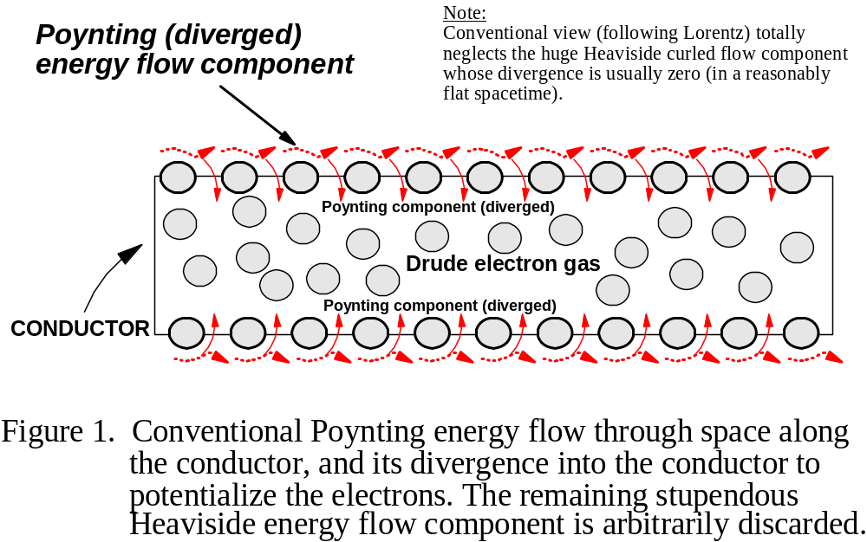

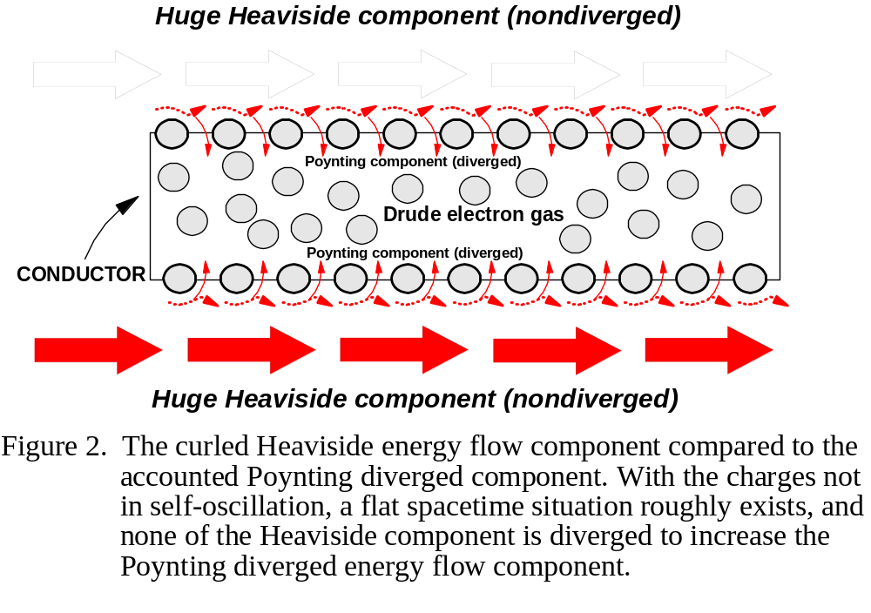
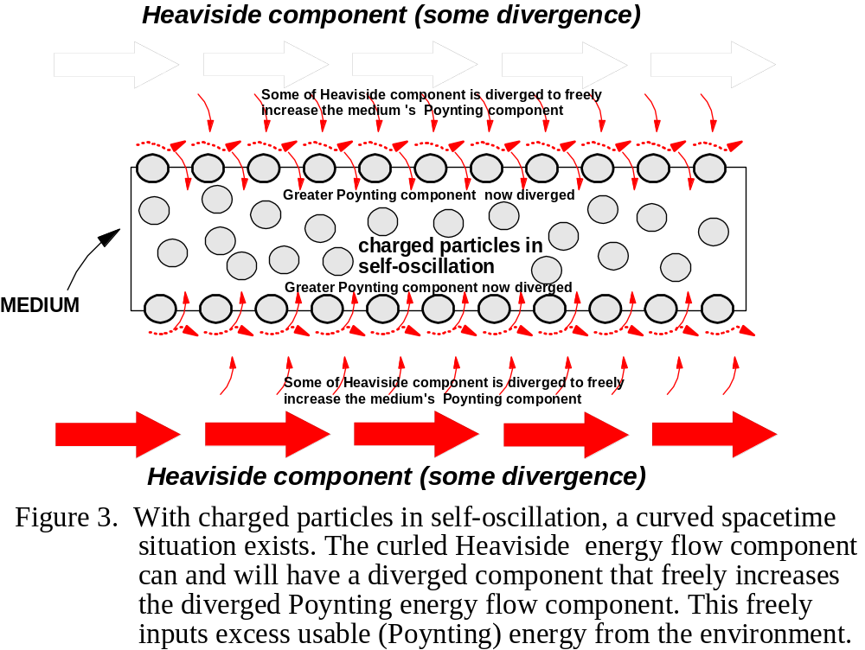

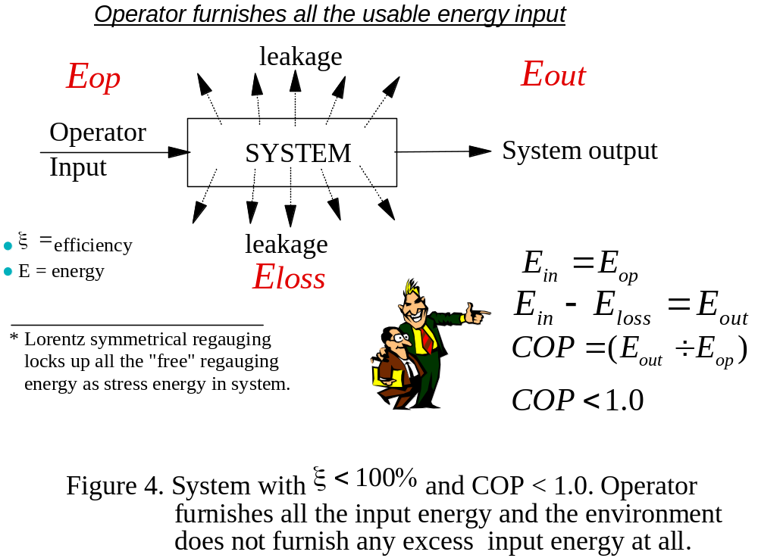
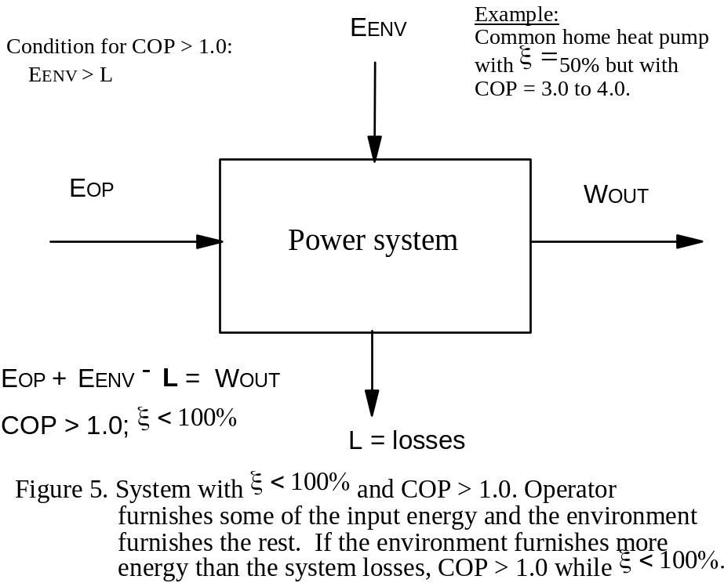

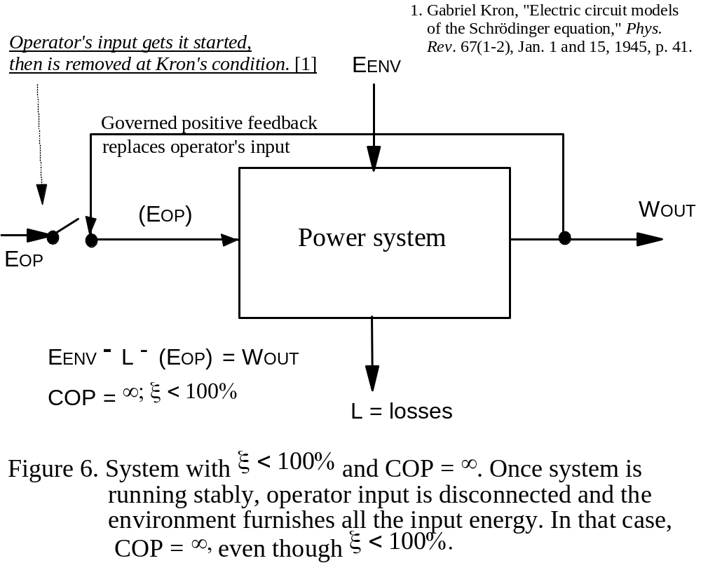
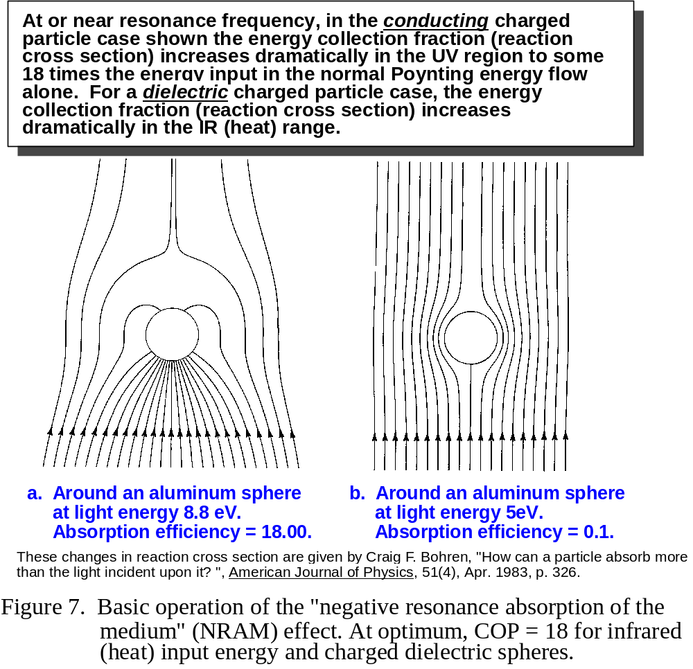
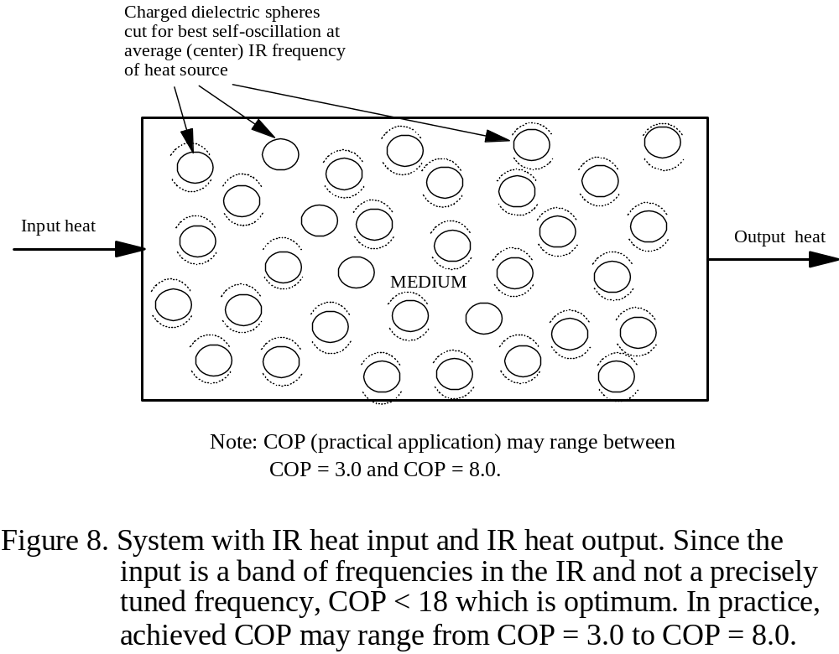
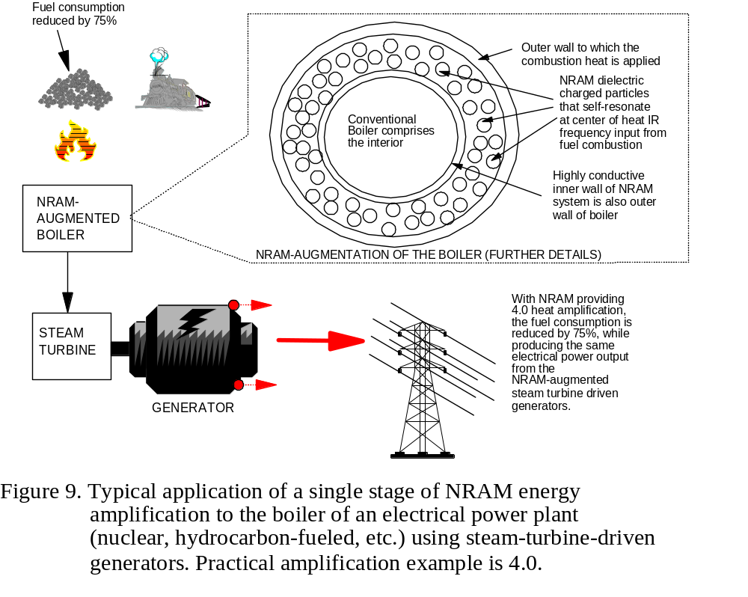
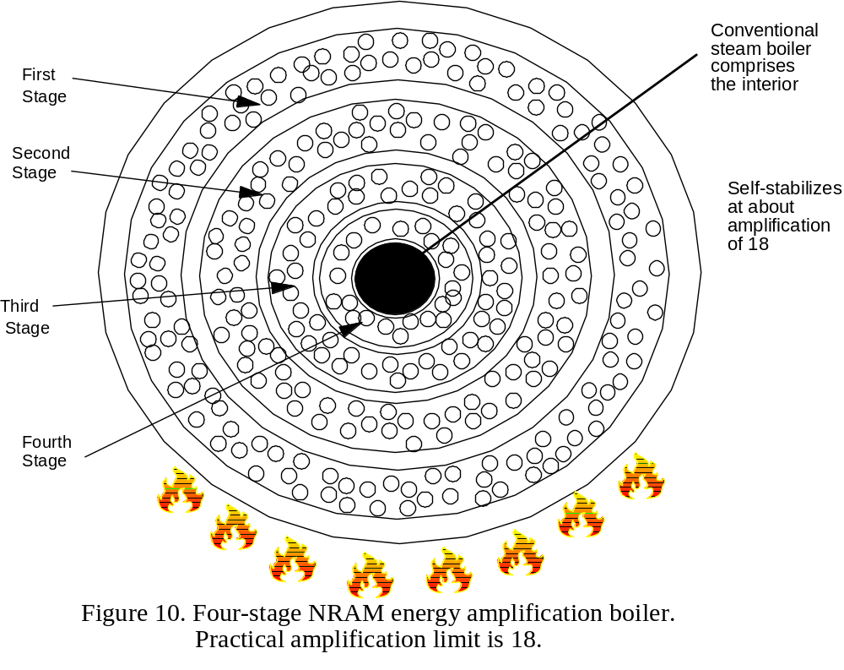
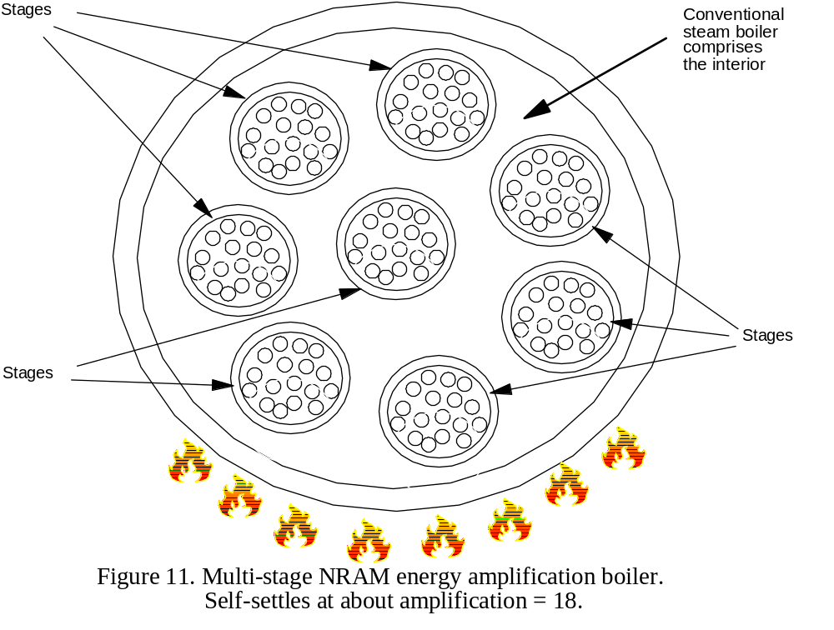
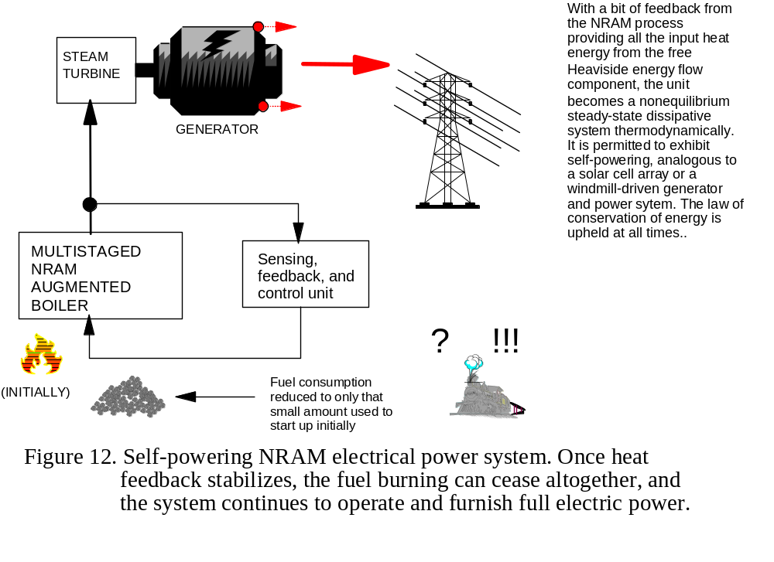
DETAILED DESCRIPTION OF THE PREFERRED EMBODIMENT
BASIC OPERATION – [Figure 7]
The standard definition of an EM force field, and its energy and force, are based on the assumption of the interaction of force-free field in space with a static charged mass. The EM spatial field is naught but a condition of space (Feynman), and only by its interaction with charged matter are the EM force field and its energy produced in that interacting charged matter. And any EM field or potential decomposes into, and is, an ongoing set of longitudinal wave energy flows (Whittaker, 1903 and 1904). How much of the flowing energy comprising the interacting spatial field that is diverged around the intercepting charged mass, therefore depends on the reaction cross section of that charge.
It has been found (Letokhov, Bohren, Paul & Fischer) that inputting the spatial energy flow in the form of the wave-envelope having a frequency at which the intercepting charge is self-oscillating, produces a much larger reaction cross section and thus more Poynting energy flow is radiated from the self-oscillating charges in the absorbing medium than is input by the operator where his “input” has been specified in static-charge terms only.
Obviously, conservation of energy requires that more energy than that standard “static charge” input calculation must have been input to the collecting self-resonant charges.
Indeed, Poynting never considered anything except the energy flow component propagating through space along the conductors that gets diverged into the conductors. He also got the flow wrong by 90 degrees and was corrected by Heaviside.
Heaviside, however, discovered that there was an additional curled-form energy flow of much greater magnitude, present and ongoing through space outside and along a conductor, but usually not diverged into the conductor. So every EM circuit and system has always had much more available EM energy flow than the Poynting component input by the operator. That is because Lorentz arbitrarily discarded the Heaviside nondiverged energy flow component, and it has remained unaccounted till the present day.
The standard CEM/EE model also assumes a flat spacetime, which is not true when energy density changes in space. The self-oscillation of the intercepting charges do vary in speed to and fro as they move, and so they involve an oscillating curvature of spacetime. General relativity thus applies. Thus the self-oscillating charges involve an oscillating energy density in space, and so their reaction cross section to the incoming spatial EM field is altered rhythmically. Because of this spacetime curvature effect, the vector algebra of flat spacetime is inaccurate, and so the divergence of the curl need not be zero. This means that the self-resonant collecting charges couple to the frequency of the input EM spatial field envelope oscillations, and that physically increases the reaction cross section of the intercepting resonant charges. In that case, the charges absorb more energy from the same wave than they would do if static. In turn, these charges radiate a greater Poynting component of energy flow (the accounted energy flow) than is calculated as being input to them in static condition.
This area of physics is known as “negative resonance absorption of the medium” or NRAM for short. This term was originally chosen apparently to prevent having to clearly state it as “excess emission by the medium” (if static calculations are used).
The end result is that, in every EM circuit and system that is active and in which EM energy is flowing, there exists not only the presently taught Poynting energy flow component but also a very much larger but presently ignored Heaviside energy flow component. Since NRAM is a method of increasing the reaction cross section of a given charge, so that excess Poynting emission occurs, it follows that NRAM circuits and systems can be utilized to deliberately intercept, diverge, and utilize additional Poynting (diverged) energy from their long-neglected Heaviside energy flow components. And since the Heaviside component may be many orders of magnitude greater than the usual Poynting energy flow component, it means that a ubiquitous, free, usable, excess energy source of enormous magnitude and importance already exists in every EM circuit and system ever built and built today.
This invention is the first invention directly addressing this NRAM process, explaining its actual mechanism for increasing the collecting (absorption) reaction cross section, and then emitting much more EM energy than was furnished by the operator himself. The excess energy was of course input by the unaccounted Heaviside energy flow environment, since some of it has been made to diverge as an additional Poynting energy component.
Researchers in the NRAM field (Bohren, Letokhov, Paul and Fischer) have clearly shown that an optimum COP = 18 can be achieved. We may speak of that as a “gain” and compare the NRAM process to an energy-amplifying process. The energy amplification is of course an amplification of the energy input by the operator, and the necessary additional input energy for that gain is input freely by the external Heaviside energy flow environment. The NRAM process also is usually self-limiting to the gain of 18 value, since increasing the EM energy output changes the frequency of the wave away from its optimum value, thus lowering the gain and reducing the output energy.
In practical single-stage systems, the single stage gain may be limited to about 4 to 8, since one will usually use available heat as input energy and the heat input is not sharply optimized in a narrow IR band as are most NRAM experiments in optical physics. The gain can be increased closer to the maximum 18 by multi-staging, in series or in a conglomerated group stage interaction as shown in this invention.
With appreciable gains of from 3 to 18, it also follows that one has developed an asymmetrical Maxwellian system, of the type arbitrarily discarded by Lorentz when he symmetrized the equations just to make them simpler and easier to solve. Hence the operation of this asymmetrical NRAM power system is not describable or modelable by the standard symmetrized Maxwell-Heaviside-Lorentz equations and model used in electrical power engineering.
Consider Figure 9, which is a typical single stage NRAM application to the boiler of an existing electrical power plant. The boiler has been converted to an inner boiler ringed by an outer NRAM section. When the heat (from hydrocarbon combustion or nuclear fuel rod consumption) is input, now it is input to the NRAM outer shell. In turn, the NRAM particles go into self-oscillation (though imperfect because of the wider bandwidth of the IR input) and produce⎯say⎯4.0 amplification. This means that burning only 25% of the coal (as shown) or consuming only 25% of the nuclear fuel rods, will heat the internal water in the boiler to the same degree and amount as would be experienced in the full fuel consumption for a non-NRAM boiler. As a result, the amount of fuel burned or nuclear fuel rods consumed is dramatically lowered (here, by 75%) whole producing the same amount of steam energy to the steam turbine driving the generator. Hence the generator produces its usual amount of electric power sent out along the attached external power transmission line to the distant loads.
Now consider Figure 10. Here multiple concentric NRAM rings are utilized for staging. This multistaged NRAM process will now produce greater amplification than 3.0, but is still rigorously limited to a gain of 18 or less.
Consider now Figure 11. Here a very special kind of multistaging is used, where we show a typical nine stages. The heat output of each of them is influenced by the output heat of all the rest, which affect and increase its input. This is a nonlinear staging, and so gains closer to the optimum 18 are realized. For a gain of 10, e.g., the consumption of hydrocarbon fuel or nuclear fuel rods may be decreased by 90%, while still furnishing the same amount and intensity of steam to the generators, and thus the same amount of electrical energy to the external transmission line and to the distant loads.
With such gains (well above 3.0), the system can be close-looped so that some of the excess energy being extracted from the Heaviside component flow in the environment can be used to replace the operator’s heat input (for which he is burning the hydrocarbon fuel or consuming the nuclear fuel rods). With this application, once the system is up and running and in stable operation, and the operator’s normal input being replaced by the input from the Heaviside energy flow component, the operator’s input can be zeroed. In short, at that point the basic power plant can cease further consumption of hydrocarbon fuel or nuclear fuel rods, while continuing to power the external transmission grid and the distant loads in normal fashion. This “close-looped” or self-powering function is permitted to any nonequilibrium dissipative thermodynamic system that freely receives all the necessary input energy from its active, energetic external environment. In this case, some of the overall energy output by the NRAM process is diverted and fed back to the operator’s input⎯or, for a boiler, to provide the outside heating to the boiler, and thereby replacing the normal nuclear fuel rod heating or hydrocarbon fuel heating input.
Such asymmetric systems were originally in the Maxwell-Heaviside equations, but were arbitrarily discarded since Lorentz arbitrarily symmetrized the equations and thereby arbitrarily discarded all asymmetric Maxwellian systems. So the system fits overall EM theory where such simplifying assumptions are not made, but it does not fit the current highly symmetrized electrical power engineering. Nonetheless, nature did not and does not discard such asymmetric Maxwell-Heaviside systems, even though our present electrical engineers and electrical power engineering science do continue to arbitrarily discard such systems. They are no more mysterious than a wind-powered electrical generator, where all the necessary input energy is freely received from the external environment. Or similarly, such systems are comparable to the solar-cell-array powered system, where again all the input energy is freely furnished by the sun.
SUMMARY, RAMIFICATIONS, AND SCOPE
There has been provided, in accordance with the invention, an energy-amplifying staged electrical power system capable of dramatically reducing or eliminating the burning of hydrocarbon fuels, consumption of nuclear fuel rods, etc. at normal electrical power plants already in existence by modifications primarily to the boiler and its input and control. The energy amplification by the NRAM process (which uses the mechanism of this invention, unknown to present NRAM scientists and researchers) is already proven in modern physics since 1967 (e.g., Letohkov, Bohren), but the source of the excess energy input has not previously been understood. Specifically, the energy amplification occurs by use of extra Poynting diverged EM energy flow freely received from the always present but previously ignored Heaviside giant curled energy flow component, in a curved spacetime. Practical COP increases of the boiler process⎯and lowering of the fuel consumption to provide the same amount of heat energy⎯of from COP = 4.0 to COP = 18 can be achieved or expected. With staging, in many cases self-powering (i.e., COP = ∞) is achievable.
The process can be applied to a non-fuel electrical power process by having a much smaller power plant first produce a heat output, and then simply apply the amplifying process with that heat as the input to it. By adding feedback controls, the system then can be made self-powering, once in operation, and the “self-starting” can be by a much smaller “power plant” as the initiator. In this way the process can be used to greatly amplify the utility and usage of wind mill initiated electrical power systems, hydroelectric initiated electrical power systems, etc.
The process is adaptable to the great majority of commercial power plants throughout the world, and to many other processes including electrical automobiles and trucks, a new kind of jet engine that burns no hydrocarbons, etc. The process when applied will also dramatically reduce the energy-related pollution of the biosphere by energy-related chemical wastes and byproducts, and will reduce the biospheric interference and damage of windmill-powered electrical power systems, hydroelectric power plants, etc. It will allow augmentation and increased COP of solar cell array electrical power systems, while assuring their continued operation when solar radiation is lacking or deficient. It will allow eventual gradual replacement of the presently highly vulnerable centralized national electrical power system to a highly decentralized national electrical power system. It will rather quickly and dramatically reduce the grave dependence of any nation on oil, natural gas, nuclear fuel, winds, solar radiation, etc. It can be adapted also to battery-powered equipment and systems, and it can be adapted to electric cars and trucks, electric locomotives, etc.
The reader will see that, by ushering in the age of asymmetrical power systems freely receiving most or all of their input energy from the giant Heaviside energy flow component ubiquitously present in (and previously ignored) all EM circuits and systems, the energy problems of the world can be solved cleanly, quickly, and in straightforward manner.
The invention has the following typical advantages:
- The system has a high output power to weight ratio, which can be increased at will by addition of higher gain stages or more stages or both.
- The system can be made highly portable for mobile applications.
- The size and output of the system are scalable.
- The system is rugged and reliable for use in hostile environments where conventional generators would fail or be extremely difficult to sustain. It can easily be environmentally shielded.
- The system has very wide operating temperature ranges for use where conventional batteries and fuel cells cannot usually function. As an example, it can power a resistance heater to keep its insulated batteries warm. It can also power electrostatic or magnetic cooling devices to keep the unit cool in higher temperature environments.
- The system has an extremely long life cycle and high reliability, allowing it to be placed where frequent maintenance is not possible.
- The system uses no fuel or fuel transport, packaging, storage, and disposal systems. The overhead and financial savings are significant.
- Use of these systems in a combined centralized and decentralized electrical power system provides survival of electric power and graceful degradation, rather than catastrophic collapse, of electrical power in the presence of damage and destruction.
- The system produces no harmful emission, harmful or radioactive byproducts, hazardous wastes, or biospheric pollutants. As its usage is phased in world wide, a significant reduction of environmental pollutants and hazardous wastes will result, as will a cleaner biosphere.
- The system can produce AC or DC power directly by simple electrical additions, and provide shaft power simultaneously.
- Coupled with driven electric motors, the system can provide attractive power system alternatives for automobiles, tractors, trucks, aircraft, boats, ships, submarines, trains, and other vehicles, again without exhaust emissions, pollutants or harmful waste products.
Although the description above contains many specificities, these should not be construed as limiting the scope of the invention but as merely providing illustrations of some of the presently envisioned preferred embodiments of this invention.
For example, the invention can be readily applied to steam ships.
As another example, the invention can be readily applied to submarines.
As another example, the invention can use a small amount of external power to produce some resistance heating, and then employ and amplify that resistance heating in a self-powering operation, disconnecting the input external power once the system is in full operation.
In ground combat forces, particularly those for fast moving situations, the burden of fuel logistics support can be materially decreased, if much of the mobile equipment incorporates the invention.
The adaptations and alterations of the embodiment are limited only by the ingenuity of the engineer and the particular needs of a given application. It is to be understood that all terms used herein are descriptive rather than limiting. Although the invention has been specifically described with regard to the specific embodiments set forth herein, many alternative embodiments, modifications and variations will be apparent to those skilled in the art in light of the disclosure set forth herein. Accordingly, it is intended to include all such alternatives, embodiments, modifications, and variations that fall within the spirit and scope of the invention as set forth in the claims herein below.

NOTE REGARDING CLAIMS
The claims for the final Patent Application will be formally and legally prepared by a skilled patent attorney so as to accurately describe the claims for this invention. In this Provisional Patent Application write-up we have included the features that will produce the major elements of the claims as we best understand them without recourse to attorney. In addition, as is customary practice, in the final Patent Application submission we will request that the Patent Examiner point out any resulting claims we may have inadvertently missed, and that he point out any relevant changes that should be made to clarify the submitted claims, and that he point out any unintended duplication of claims should such inadvertently occur.]

